SARAH Abbas NEAMA

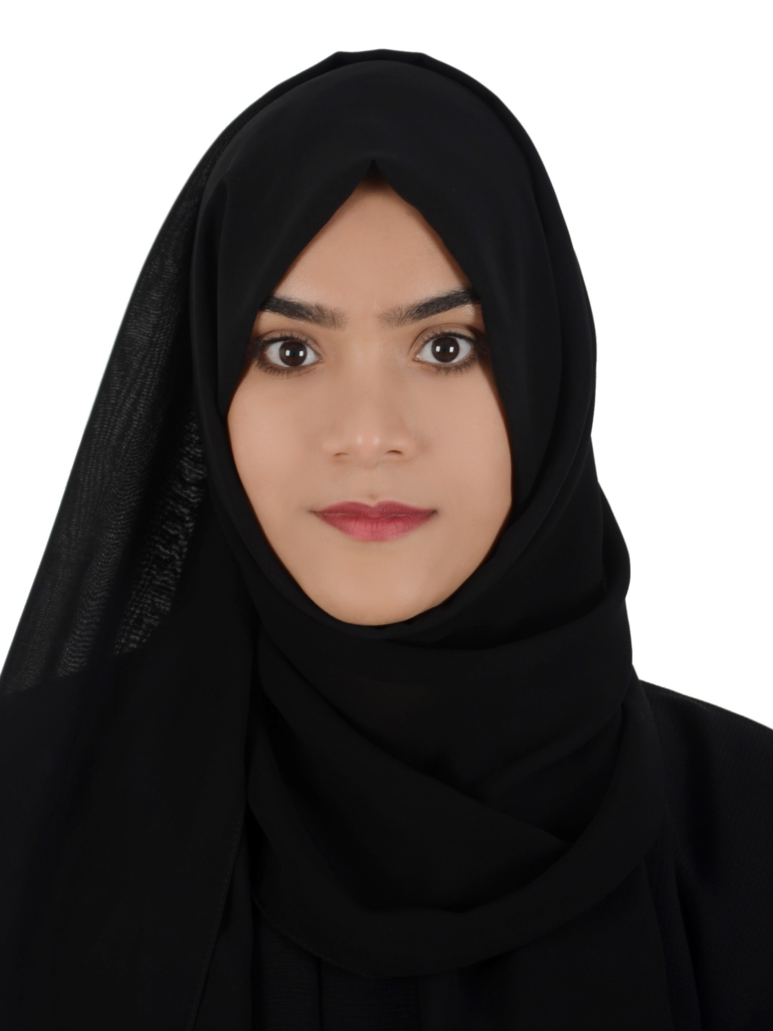

**CPR** 910608083

**Nationality** Bahraini

**Telephone** 66656611

**Email** [Sarahneamah91@gmail.com](mailto:Sarahneamah91@gmail.com)

**Address** House 2876 Block 1037 Road 106 Sadad - Northern Governorate – Bahrain

# Objective

To work for an organization that will give me the opportunity to learn, develop and contribute to the organization and myself.

# Work Experience

## Ministry Of Education

* Data entry "Trainee"

## Karakish line shop

* Receptionist & Sales

## Alharam Company

* Sales Supervisor

# Education

June 2013 to October 2013

March 2014 to June 2016

October 2018 - Present

## Bahrain Training Institute

* National diploma in Information technology

## Alahed Alzher school

* Secondary school

# Languages

Arabic — Fluent

English — Good

# Skills

* Motivated and fast learner
* Good attention to details
* Good user of MS Office
* Independent and Co-worker
* Little knowledge in LMRA

2009 to 2012

**Sh. Latifa Al Kalifa** from Ministry of Education

Telephone: 17878720

**Abbass Hassan** from Karakish line

Telephone: 39292083

**Salman Faqeehi** from Alharam Company

Telephone: 66915510

# References

2006 to 2009